LAB EXERCISE 1

QUES 1->

Linux is open source and open to use whereas windows is proprietary.

In Linux monolithic kernel is used. While in windows, microkernel is used.

In Linux, file naming convention is case sensitive. Hence abc and ABC are 2 different files.

Whereas in windowa, we cannot have 2 files with same name in same folder.

QUES 2->

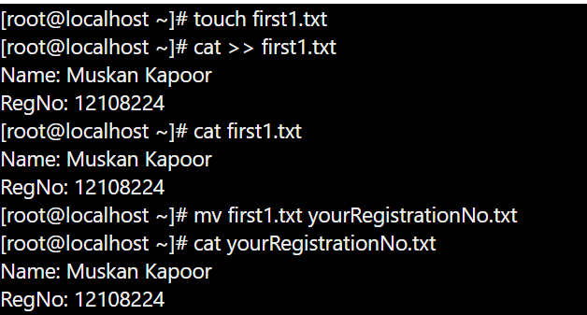

QUES 3->

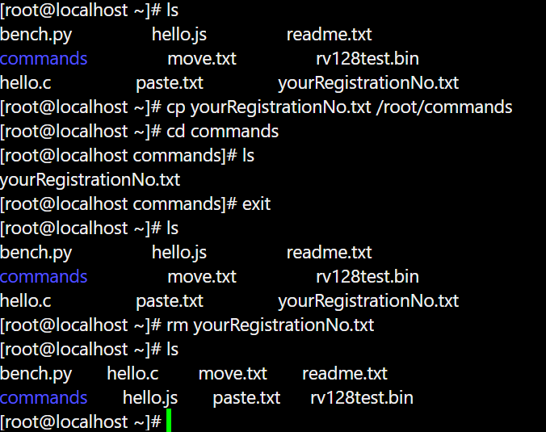

QUES 4->

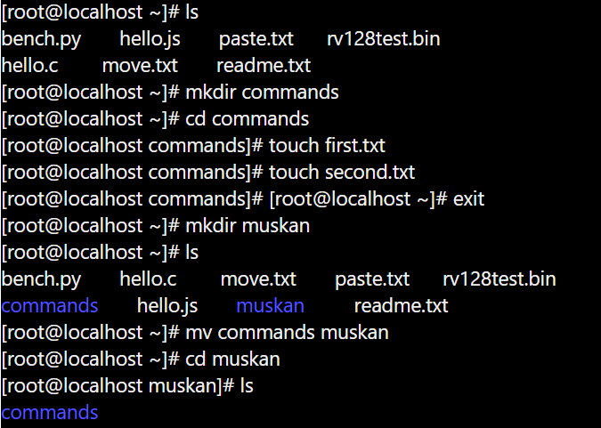

QUES 5->

